Grade Reports

- STEP 1: Enter Chapter & Term
  - EX:
    - Chapter: Founding Chapter
    - Term: Fall Quarter 2026
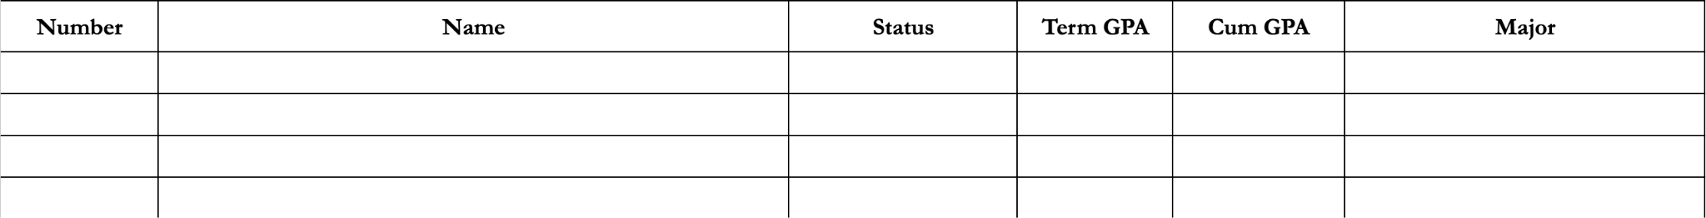
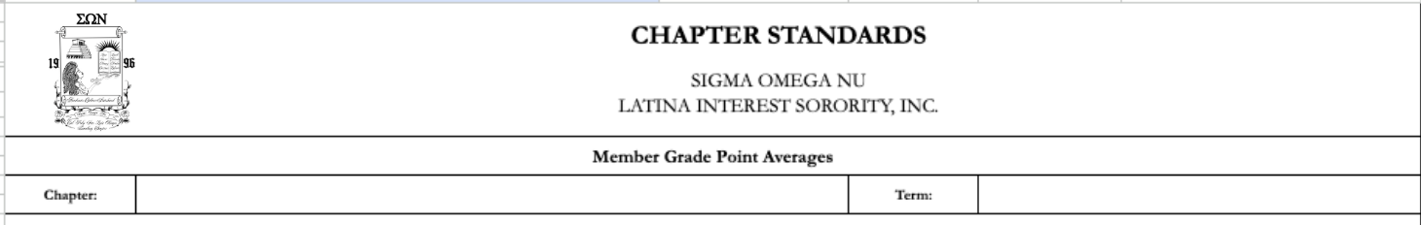
- Step 2: Enter member information
  - Add more lines if needed:
    - Insert - Rows - Insert 1 row below
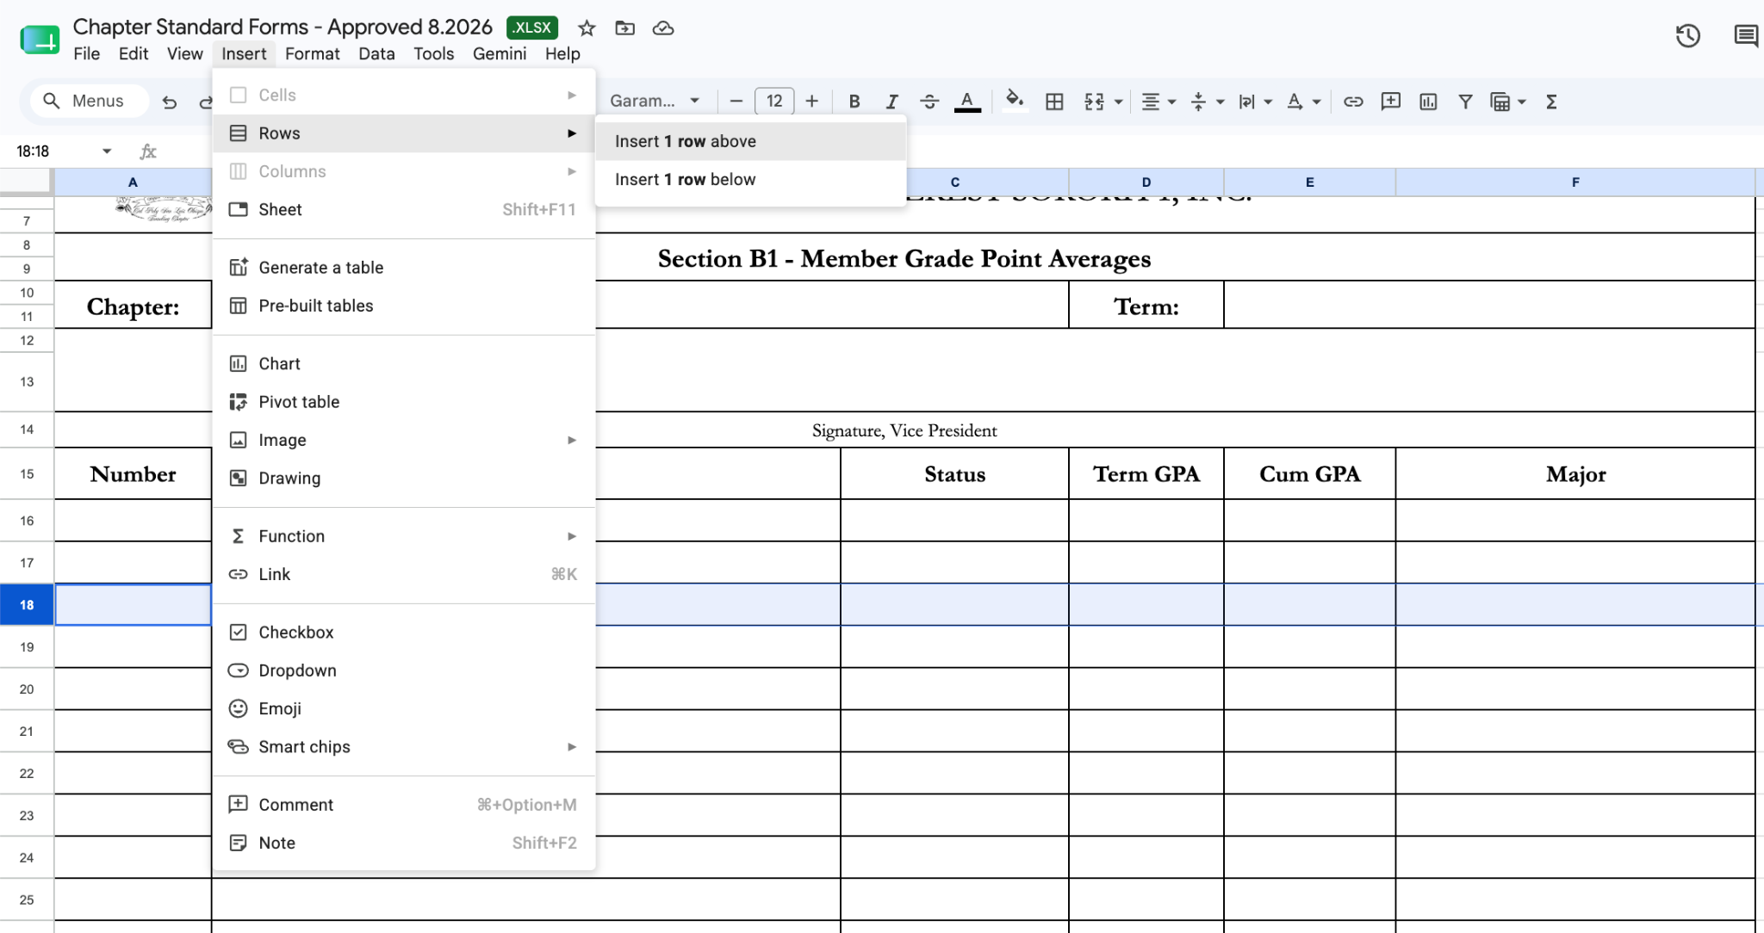
- Take an average:
  - =AVERAGE( *CLICK/HIGHLIGHT ROWS W/ GPAs*)
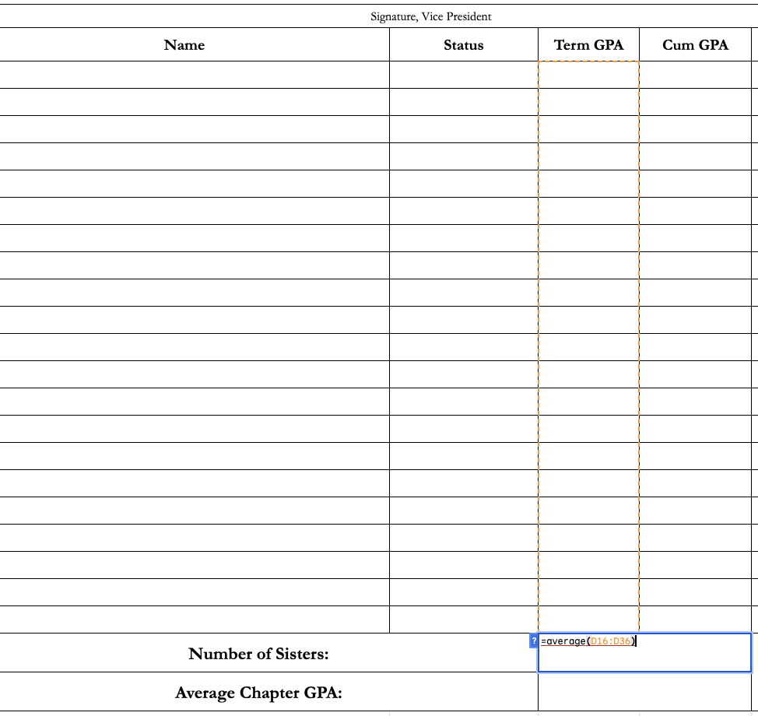

- Wet Signature from VP

